N.6 / November 6, 2023, Parma

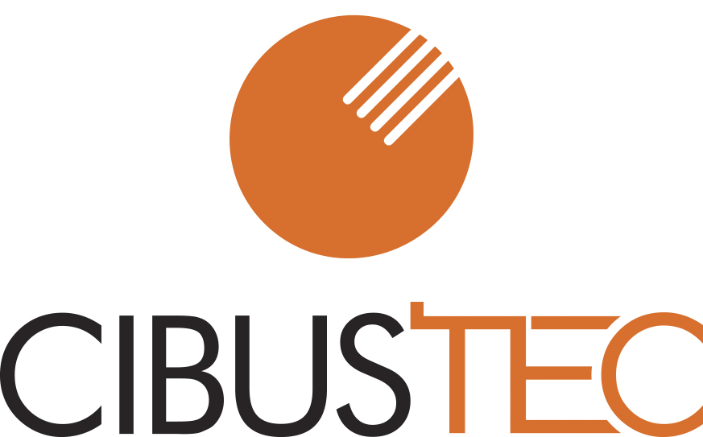
Cibus Tec concludes an event that enjoys great popularity worldwide and reconfirms itself as one of the international reference events for the food & beverage technology industry.

The 2023 edition of Cibus Tec was successfully archived, reaffirming Parma as the capital of technological innovation for the food and beverage industry. At the fair, 1,200 companies from over 30 countries have chosen this stage of excellence to present their cutting-edge solutions and 40,000 visits from the food & beverage sector, eager to explore the trends and the best news.
Cibus Tec
24.10.–27.10.2023
www.cibustec.it

Contatti:
Amina Piciotti
Mob.
+39 339 6541776
E-mail
a.piciotti@media-ambience.com

Koeln Parma Exhibitions Srl
Viale delle Esposizioni 393a
43126 Parma (PR)
Italia

Presidente:
Thomas Rosolia

Amministratore Delegato:
Antonio Cellie

Success also for the Top Buyers Program, developed with ICE-Agenzia and with the support of the Emilia-Romagna Region which allowed over 3,000 top buyers from 80 countries to be welcomed to Parma with 10,000 requests for appointments scheduled even before the start of Cibus Tec.

Around 150 accredited journalists from Italian and foreign media guaranteed global coverage of the event with a clear increase compared to the past in areas such as North America, the Middle East and Spanish-speaking countries.

Thomas Rosolia, President of Koeln Parma Exhibitions comments on the closing of Cibus Tec 2023 as follows: “We are very happy with the numbers achieved in this edition; Cibus Tec 2023 involved a vast international community that recognizes this territory as the excellence of resources and technologies related to agri-food. Thanks to the network generated by Koelnmesse's portfolio of 20 already established Food&Foodtec events, I can today also state that the expected attendances have largely been achieved, with thousands of visitors coming from Italy and over 100 foreign countries. This year we also managed to increase the number of Italian and foreign exhibitors and the quality of the exhibition offer".

Numbers which for Antonio Cellie - CEO of Koeln Parma Exhibitions - are the reconfirmation that collaborations at an international level also help Made in Italy grow: “Cibus Tec is increasingly a model of fair that is popular because it brings with it an appreciated brand heritage and, all things considered, inimitable: the companies that choose to exhibit here register their name in a historic hub of knowledge, in which experiences, creativity, courageous projects and innovative solutions with very high added value have been collected for more than 80 years. In this sense, being able to host a show in Parma that brings 40,000 visits to come face to face with the best of technology applied to the food and beverage sector means offering participating companies much more than a space at the fair, but a solid system of global relations; a system that the partnership with Koelnmesse is significantly increasing, while also refining its qualitative profile".
There are more than 50 conferences and special events that have explored the most attractive themes of the sector, from innovative packaging to food safety, from the role of Artificial Intelligence and IoT to new professional figures, passing through sustainability. A total of over 80 hours of programming that make Cibus Tec a one-of-a-kind networking and training platform. The closing of the four days of work was entrusted to the Tomato News Conference, a prestigious event that attracts all the most important national and international operators in the industrial tomato sector to take stock of the state of the art and prospects of the supply chain.

Cibus Tec is looking forward to the next edition scheduled for 27 to 30 October 2026; preceded in 2025 - on 28 and 29 October - by the second edition of Cibus Tec Forum, the Exhibition Conference on Trends in Food and Beverage Technologies.

Koelnmesse – industry trade fairs for the food technology sector: Koelnmesse is an international leader in organising trade fairs in the field of food and beverage processing. Anuga FoodTec and ProSweets Cologne are established, world-leading trade fairs, hosted in Cologne/Germany. In addition to the events at its Cologne headquarters, Koelnmesse also stages further food technology trade fairs with different sector-specific areas of focus and content in key markets across the world, including India, Italy and Colombia. These global activities enable Koelnmesse to offer its customers bespoke events and leading regional trade fairs in a variety of markets, thus creating the foundation for sustainable international business. Koelnmesse is also ideally positioned in the field of food and beverages with its leading international trade fairs Anuga and ISM and its global network of satellite events.

Further information: www.anugafoodtec.com/trade-fair/anuga-foodtec/industry-trade-fairs

Upcoming events:

Andina Pack, Bogotá, Colombia, November 27-30, 2023
Prosweets Cologne, Cologne, Germany, January 28-31, 2024
Anuga FoodTec, Cologne, Germany, March 19-22, 2024

Editor's Note:
Images and logos of Cibus Tec are available in the "News & Press" section of the website www.cibustec.it

Cibus Tec on LinkedIn: https://www.linkedin.com/showcase/cibus-tec

Cibus Tec on Twitter: https://twitter.com/CibusTec

Contacts:
Amina Piciotti
Cibus Tec Press Office
Mobile: +39 3396541776
a.piciotti@media-ambience.com

